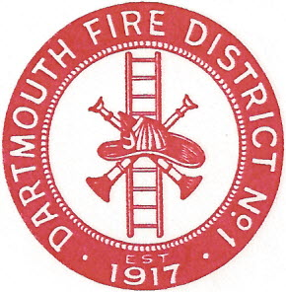
Dartmouth Fire District No.1
10 Bridge Street • Dartmouth, MA 02748
Telephone (508) 996-1596 • Fax (508) 984-4521

Agenda for December 17, 2015 @ 7:00PM

- Second meeting with Brian Gallant, candidate for fire chief
- Meeting minutes-12-10-2015
- Adjourn

